1. **Agenda**: Let me give you some overview over how exactly you will work with mongodb and what mongodb exactly does behind the scene when we talk with mongodb with some programming language.
2. We generally differentiate b/w app and data layer. 
3. **Application:**
   1. **Frontend**: It can be single page app or mobile app, views your app renders.
   2. **Backend(server)**: Where you have server side logic.
   3. **Drivers**: Different drivers for different languages. These interact with the mongodb server.
4. **Data Layer**:
   1. It has database (Data Storage the files on the file system where data is stored eventually).
   2. It has mongodb server which is started with command **mongod command**.
   3. Mongodb server will not directly write data into the files but will talk to co-called **storage engine** which you could replace with your favorite storage engine but the **default** one is called **Wired Tiger** that is actually awesome storage engine which allows you to efficiently work with your data. Store it efficiently and so on.
5. 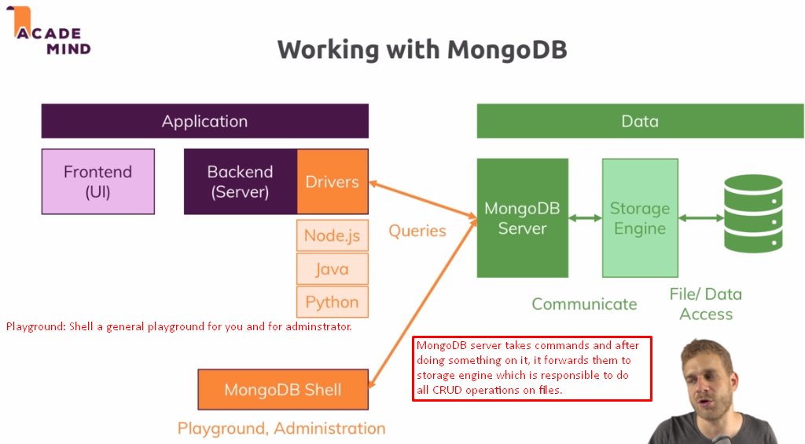
6. Let’s have a closer look at the Data Layer.
7. Storage engine actually read and write into files and into memory too. Reading and writing into memory are fast as compared to files.  
   Storage engine keeps the frequently accessed data into the memory or loads into memory from files for fast speed.
8. 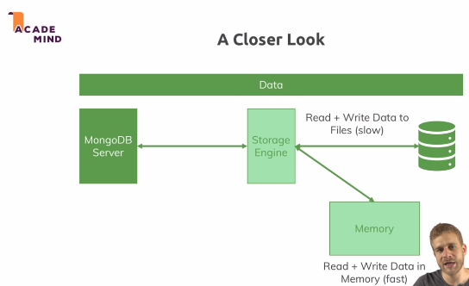
9. Finally storage engine stores the data from memory into files.